Experiment No.: 03 Date: / /

Comparator
AIM: Design and analyze
- 1-bit comparator using Logic Gates
- 4-bit magnitude comparator using IC 7485
EQUIPMENTS & COMPONENTS:
- Digital Trainer Board
- IC 7404, 7400, 7432, 7485
THEORY:
A magnitude digital comparator is a combinational circuit that compares two digital or binary numbers in order to find out whether one binary number is equal, less than or greater than the other binary number. We logically design a circuit for which we will have two inputs one for A and other for B and have three output terminals, one for A > B condition, one for A = B condition and one for A < B condition.
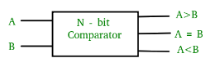
Figure-1: Block Diagram of Comparator
- 1-bit Magnitude Comparator:
A comparator used to compare two bits is called a single bit comparator. It consists of two inputs each for two single bit numbers and three outputs to generate less than, equal to and greater than between two binary numbers. The truth table for a 1-bit comparator is given below:
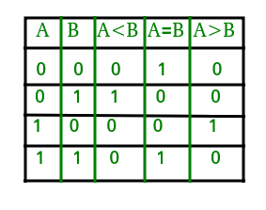
Figure-2: Truth Table of 1-Bit Comparator
From the above truth table logical expressions for each output can be expressed as follows:
A > B: AB'
A < B: A'B
A = B: A'B' + AB
By using these Boolean expressions, we can implement a logic circuit for this comparator as given below:
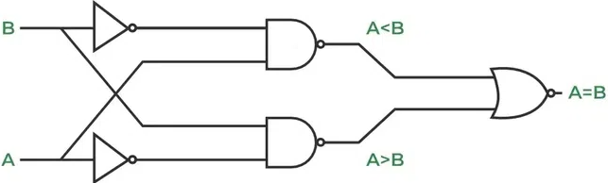
Figure-3: Gated Diagram of 1-Bit Comparator

- 4-bit magnitude Comparator:
IC 7485 is used to compare magnitude of two binary numbers .The two 4-bit numbers are applied at the inputs A3,A2,A1,A0 and B3,B2,B1,B0 Where A3 and B3 are the most significant bits of the two 4-bit operands to be Compared. The Three cascading inputs (A = B) IN, (A < B) IN and (A > B) IN should be connected to logic '1'(HIGH), logic '0'(LOW) and logic '0'(LOW) respectively. The Three outputs (A > B) OUT, (A = B) OUT and (A < B) OUT will reflect the results of comparing the two 4-Bit numbers A=A3A2A1A0 and B=B3B2B1B0.
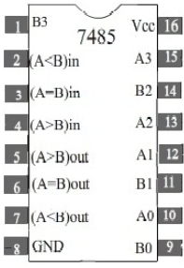
Figure-4: Pin Configuration of 4-Bit Comparator IC 7485

Observe the outputs listed in the compressed function table given below
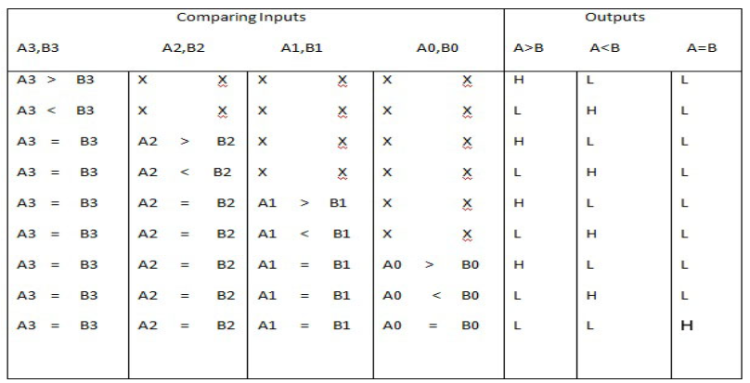
PROCEDURE:
- Place the IC on the Trainer Board/Bread Board.
- Connect VCC and ground to respective pins of IC Trainer Kit.
- Connect the inputs to the input switches provided in the IC Trainer Kit.
- Connect the outputs to the switches of O/P LEDs,
- Apply various combinations of inputs according to the truth table and observe condition of LEDs.
- Verify the Functionality of 1-bit comparator and 4-bit comparator.

CONCLUSIONS:

